Summer 2 week 1

Dear Parents/Carers,

This week we have learnt about the artist Frida Kahlo and how she kept practising her painting and drawing even when she was in hospital.

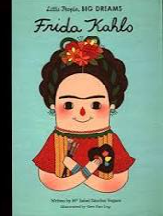

In literacy, our focus text has been ‘Each, Peach, Pear, Plum’ by Alan and Janet Ahlberg. We are focusing on your child’s ability to hear rhyme. This is important skill when learning to read using phonics.

In maths we have been looking at data and we made a realia graph.

We have been practising using scissors, as this helps our fine motor development ready for writing in Reception.

HOMEWORK

Please re-read ‘Each, Peach, Pear, Plum’ by Alan and Janet Ahlberg. Pause before the end of the sentence and see if your child can fill in the rhyme. This will help with their phonics assessment.

If you do not have the book at home, there is a hyperlink below and you can mute the sound and read and pause yourself.

<https://www.youtube.com/watch?v=N17fprE1SxU>

Kind regards