Summer 2 week 5 -***A COPY OF THIS LETTER IS AVAILABLE ONLINE FOR CLICKING ON HYPERLINKS***

Dear Parents/Carers,

This week we have read the book ‘Doing the Animal Bop’ by Jan Ormerod in Literacy. This book is excellent for teaching children to listen for rhyme (phonics skill} and also teaching the following TIER 2 VOCABULARY ‘**flounce**’ and ‘**jive**’. Please go through this book at home with your child. There is a link below if you do not have a copy.

<https://www.youtube.com/watch?v=H4UukgIeuWc>

In PSRHE, we have focused on the text ‘Hear, Head and Hands’ 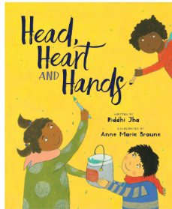. There is a snippet in the hyperlink below for you to get an idea of the materials we are using in PSHRE.

<https://www.youtube.com/watch?v=Jg8C5J4Z_a8>

In science, PD and maths, we have been building a Bug Hotel. We have been looking at some information in ‘The Big Book of Bugs’ by Yuval Zommer. This is to expose children to non-fiction texts as well as fiction.

Please remember that our zoo trip is next week.

HOMEWORK

Please read through ‘Doing the Animal Bop’ again with your child and act it out with them. In maths, please check if your child knows their basic 2D shape, what ‘longer’ and ‘shorter’ mean, ‘backwards’ and ‘forwards’ and how to touch count ACCURATELY to 10.

Kind regards

S Van Cook