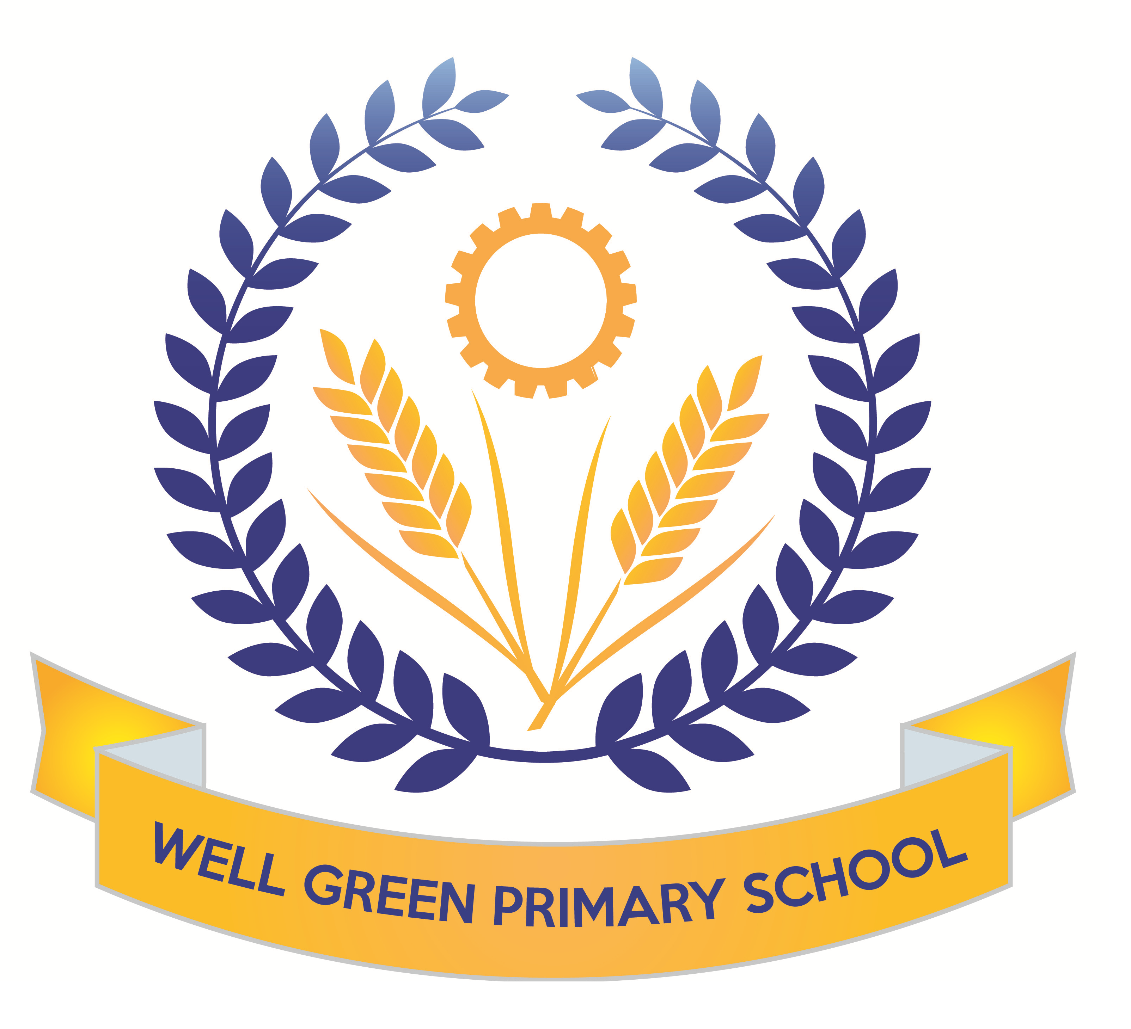

Well Green Nursery Autumn 2 2019

Welcome to nursery! We hope you have all had a great holiday. This half term we will be supporting the children in…
Personal, Social and Emotional Development | - To begin to take turns and share resources  - To select and use activities and resources  - To talk to other children when playing
Communication and Language | - To respond to simple instructions consistently  - To listen attentively to others one to one or in small groups  - To begin to understand ‘why’ and ‘how’ questions
Physical Development | - To use two fingers and thumb to hold pens and paintbrushes  - To use scissors to snip paper  - To draw lines and circles using gross motor movements  - To understand why equipment and tools have to be used safely
Literacy | - To listen to, and joins in with, stories and poems, in small groups  - To suggest how the story might end  - To look at books independently  - To give meaning to marks as they draw and paint
Understanding the World | - To talk about significant events in their own experience  - To know some of the things that make them unique  - To talk about some of the things they have observed
Mathematics | - Recites numbers in order to 10  - To know that numbers identify how many objects are in a set  - To count sounds or actions such as claps or jumps  - Shows awareness of similarities and differences in 2D shapes
Expressive arts and Design | - To create movements in response to music  - To use various construction materials  - Realises tools can be used for a purpose

Your child must have a full change of clothes to be kept on their peg in nursery to save any upsets should they need to get changed.

Thank you for your continued support. The Nursery Staff.

