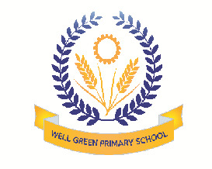

Welcome back! We hope you all had a great holiday. Our Learning Challenge for this half term is: How Many Nursery Rhymes Do We Know? The children will be focusing on:

Communication & Language | - Developing Learning Challenge vocabulary  - Remembering Talk Partner conversations  - Talking about change, special events and places
Physical Development | - Continuing to develop finger strength  - Holding scissors and pencils correctly and effectively  - Thinking about self-regulation to ensure safety
Personal, Social & Emotional Development | - Learning to take turns and share  - Enjoying the responsibility of carrying out small tasks  - Playing in pairs and small groups
Literacy | - Talking about a story’s beginning and end  - Hearing and saying the first sound in words  - Mark making and writing familiar words and names
Mathematics | - Representing numbers using fingers and marks  - Reciting numbers to 10, 20 and beyond  - Describing shapes and using them during tasks
Understanding the World | - Talking about events and people in their lives  - Recording observations using the camera and iPad  - Learning about occupations and ways of life
Expressive arts and design | - Capturing experiences in different ways: drawing, collage…  - Role playing with friends to develop a storyline  - Using construction materials with a purpose in mind

Thank you in anticipation of your support and co-operation. Well Green Primary School Nursery Staff

