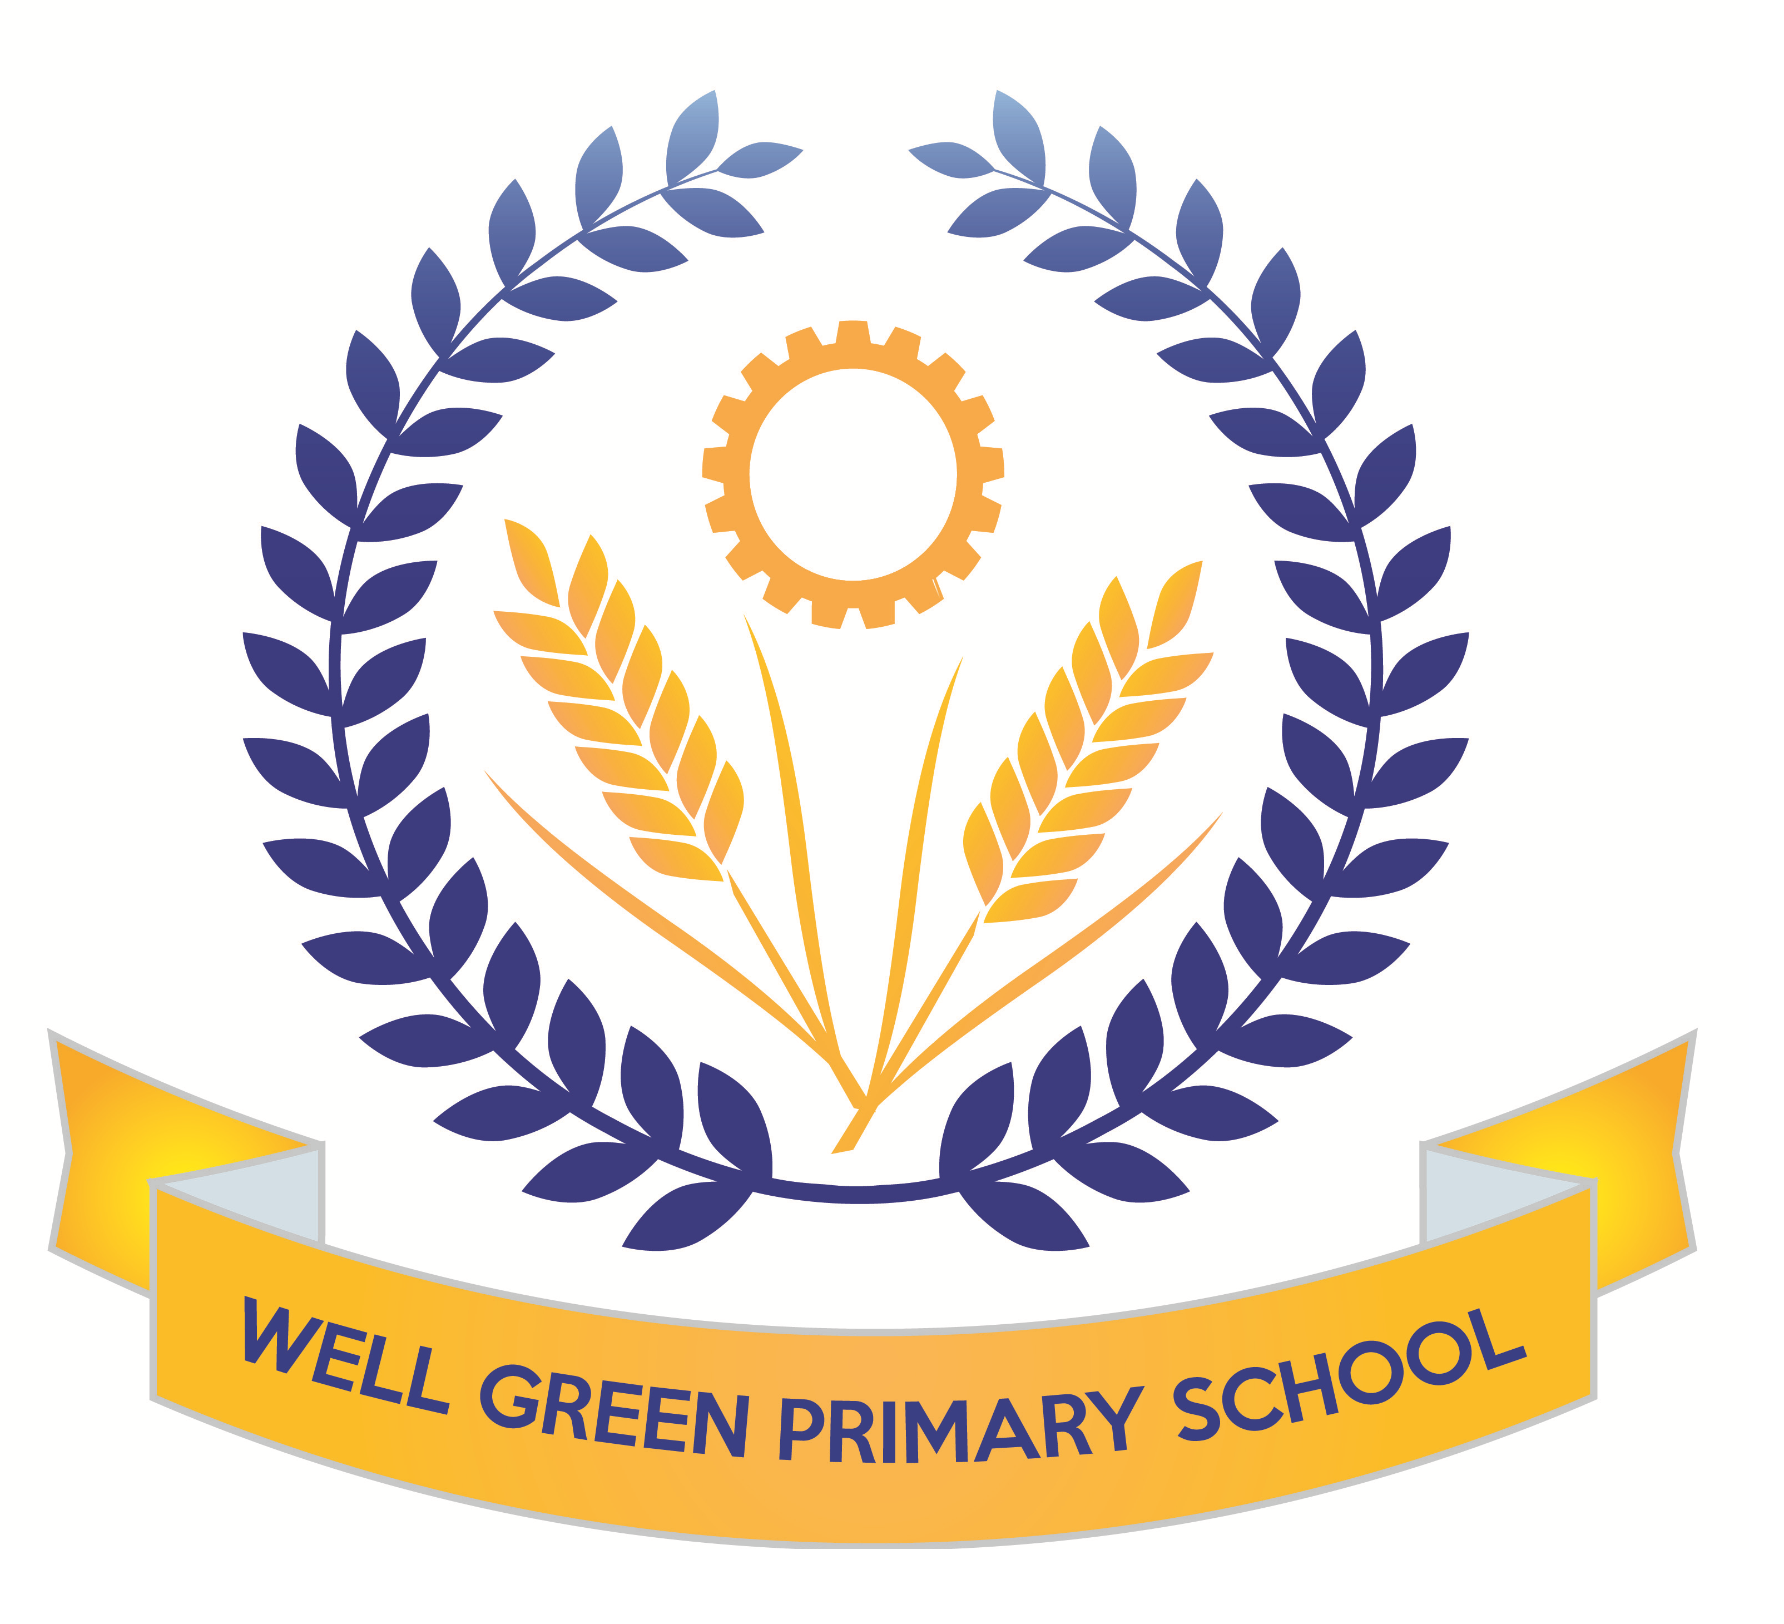

This half term (Spring 2) Year 6 will be learning about the following topics and be working towards these key targets:
English | In English, we will be covering the following texts: Discussion, Poetry- haikus, Narrative writing and reports. We will focus on William Wordsworth’s Daffodil poem for our poetry week and create our own versions. World Book Day: Kensuke’s Kingdom with linked writing and topic work to create a ship’s log, newspaper report and suspense story. Grammar: SPAG rules, complex sentences, investigating conditional and modal. Past participle and progressive and perfect tenses, types of pronouns.  Spelling: using rules and exceptions, suffixes and prefixes, root words. Key revision of words on Y5/6 curriculum list.
English targets | - To revise all key concepts of SPAG covered  - I can use semi-colons, colons or dashes to mark boundaries between independent clauses and use a colon to introduce a list  - I can use appropriate verb tenses with the past participles  - I can further develop my understanding of adding prefixes and suffixes to root words  - I can spell all words from the Y3/4 list and most words from the Year 5/6 list  - I can answer questions about a range of texts using inference and commenting on the use of language and how this contributes to overall meaning and provide quotations for 2 and 3 marks  - I can answer questions about fact and opinion in a text
Mathematics | We will be covering a range of shape, geometry and measures work. We will be calculating the area and perimeter of shapes, including triangles and parallelograms. This will involve working out volumes of cuboids. We will also be learning about conversions of different units as measures, including metric and imperial measures. We will be continually working on arithmetic skills to calculate number questions, including the four operations with fractions. The children will develop their understanding and recognition of Roman Numerals.
Maths targets | - To develop calculations skills using written arithmetic, including to calculate fractions  - To be able to read and write numbers with Roman Numerals  - To calculate area and perimeter of shapes  - To solve equations with unknown variables  - To solve problems with measures and converting different units.  - To be able to solve multi-step problems using reasoning
Science | We will be finding out about electricity in our science work. We will build on work covered lower down school to construct circuits in parallel and series and test the brightness of bulbs and make buzzers and switches operate. We will use correct scientific symbols to record circuits. The children will carry out practical investigations in addition to developing their understanding of electrical safety and sustainable energy sources.  We will be covering revision topics for materials and properties, microorganisms and space.
Computing | We will be working on a theme about Networks and Online Safety  Research and find out about the internet  Understand LAN and WAN  Understand about online safety and how behaviour impacts others  We will focus on E-Safety and staying safe online, including responsible use of social media and mobile phones.
P.E. | We will be following a set of sessions from Sale Sharks to develop our tag rugby skills. We will be learning about the rules of the game and the fats paced nature of the ball throwing skills.  For our outdoor sessions, we will be covering Netball skills to be able to develop team tactics to score and pass the ball. We will play in different positions and discuss match skills and rules of the game.
Music | Working with Mrs Cooper, Sounds & symbols, Pitched notes to create melody  Easter songs and hymns for our concert.
DT | This half term, the children will develop their use of science and electrical circuits to design and make an electrical item such as a wire hoop game. They will consider the types of materials and the finished product design for being user friendly and economical. The children will focus on their circuit and switch combination to use series and parallel aspects of design.
Art and Design | The children will use the theme of rivers to continue to think about the textures and colours in the river landscape. We will use fabrics and materials to complete weaving using lose weave hessian materials to replicate the river landscapes.
R.E. | The children will focus on the question: what difference does it make to believe in Ahimsa (harmlessness), Grace (the generosity of God) and Ummah (community)? They will make connections between beliefs and behaviour in different religions for Christianity, Islam and Hinduism. The children will learn about Easter traditions and religious celebration for Christians and how they celebrate this major festival.
P.S.H.E. & Citizenship | We will be developing our knowledge of zones of regulation to think about how we can move between zones and manage our behaviours.  We will also be completing some work in conjunction with the NSPCC about PANTS and staying safe.  As part of the theme, ‘Good to be Me’ The children will be discussing strategies for dealing with anxieties and worries (linked to exams and secondary school transitions) and using assertiveness. Individual Liberty will be our focus for British Values and we will discuss Growth Mindsets in more detail to talk about realistic and achievable goals based on our own abilities.
French | The children will consolidate their conversational skills with places around town and ‘then and now’. They will develop their vocabulary and learn about Easter customs and traditions in France.
Geography | For our geography work this half term, we will visit Styal Mill to learn about rivers and fieldwork investigations, We will also develop map reading skills to follow a trail. This half term we will be using the book, Kensuke’s Kingdom, to cover some mapping skills. We will be using maps to find 8 point compass directions, 6 figure grid references, plotting time zones on world maps and plotting a course to sail around the world.
History | In history, we will be exploring Victorian inventions and significant technological innovations. We will research and create a short timeline of the inventions and study the ongoing impacts of the following famous Victorian inventors: Isambard Kingdom Brunel, Alexander Graham Bell and Pierre and Marie Curie.
Weekly homework will be handed out on Friday, to be returned to school by the following Wednesday.

Booster classes will be running this half term, beginning the first week after half term until the week before SATs.
Spelling Test: Friday Mental Arithmetic Test: Wednesday
Sale Sharks (outdoor): Friday Netball (outdoor): Friday

Please can you also ensure your child has the correct equipment required for school: A blue cartridge pen with spare refills, pencil, ruler, glue stick and eraser and a whiteboard pen please. They also require a named water bottle.

Thank you for your support and co-operation.
Mrs Burnham

