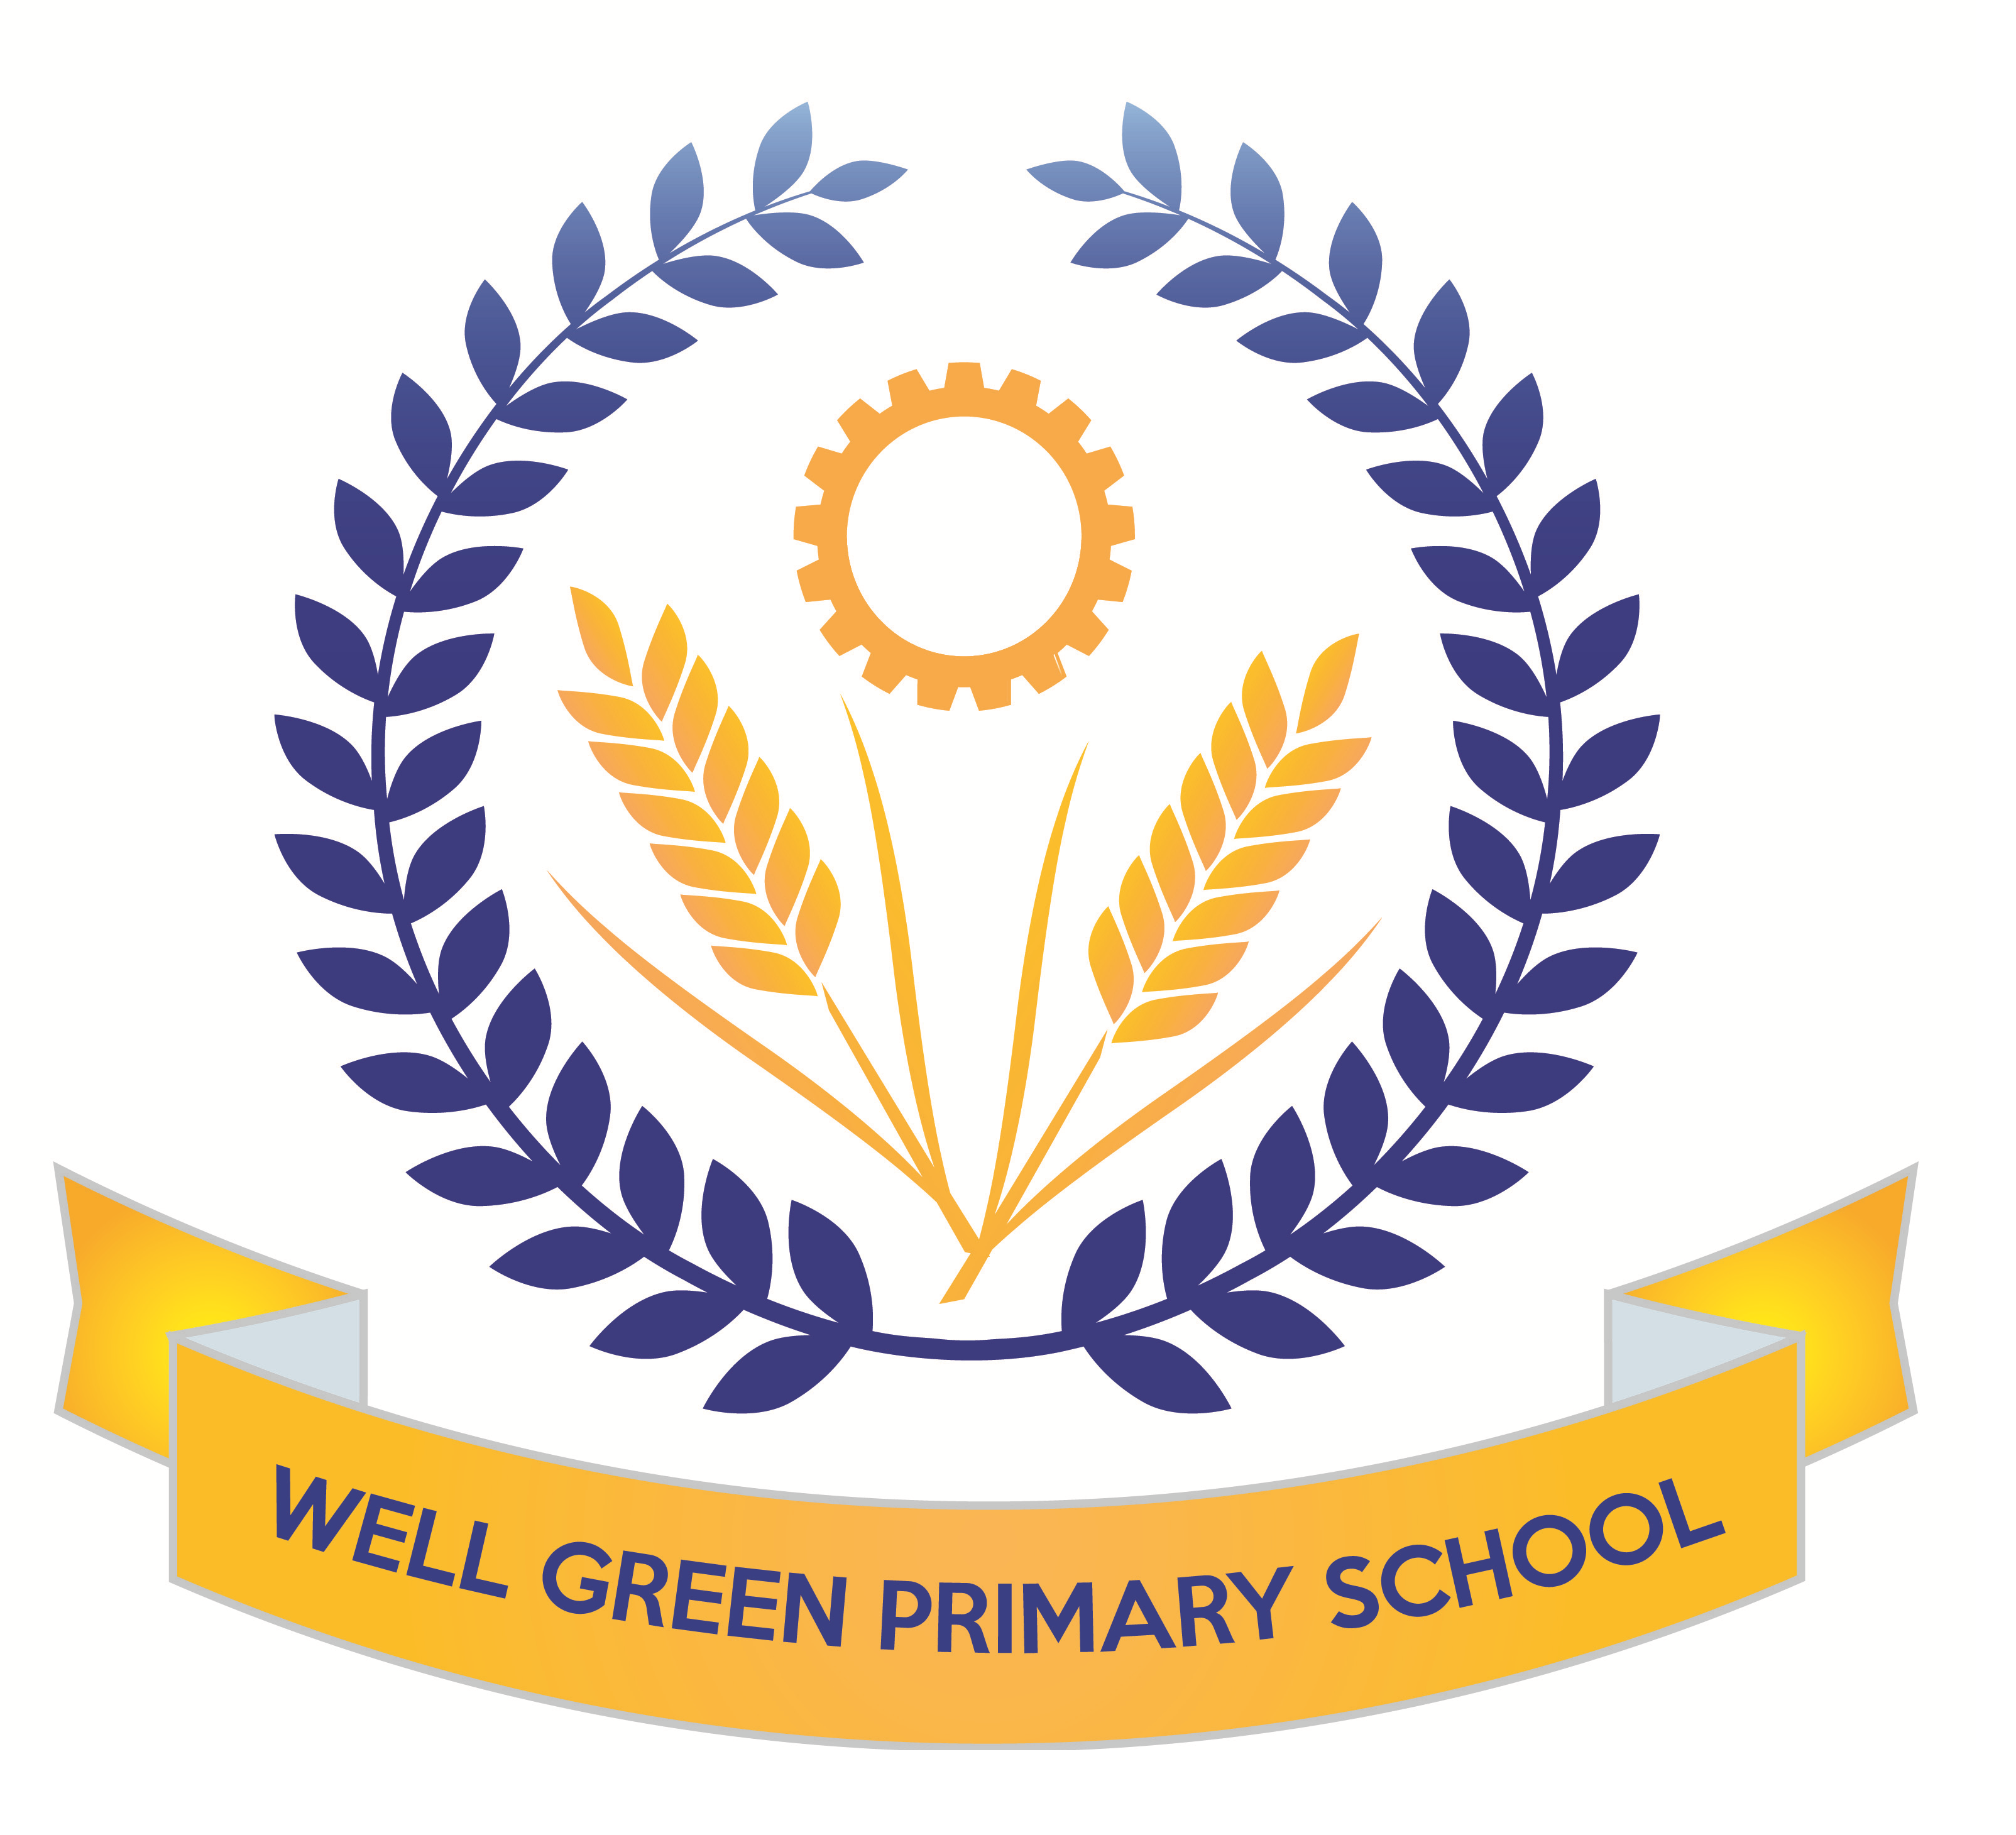

This half term (Spring 2) Year 6 will be learning about the following topics and be working towards these key targets:
English | In English, we will be covering the following texts: Discussion, Poetry- range of forms and haikus, Narrative writing, reports, formal and explanation texts, Book Week: Kensuke’s Kingdom with linked writing and topic work to create a ship’s log, newspaper report and suspense story. Grammar: SPAG rules, complex sentences, investigating conditional and modal, Past participle, types of pronouns.  Spelling: using rules and exceptions, suffixes and prefixes, root words. Key revision of words on Y5/6 curriculum list.
English targets | - To revise all key concepts of SPAG covered  - I can use semi-colons, colons or dashes to mark boundaries between independent clauses and use a colon to introduce a list  - I can use appropriate verb tenses with the past participles  - I can further develop my understanding of adding prefixes and suffixes to root words  - I can spell all words from the Y3/4 list and most words from the Year 5/6 list  - I can answer questions about a range of texts using inference and commenting on the use of language and how this contributes to overall meaning and provide quotations for 2 and 3 marks  - I can answer questions about fact and opinion in a text
Mathematics | We will be covering a range of number work and calculation revision. We will focus on pie charts, properties of circles and mean, mode and range. We will also consolidate data handling to be able to solve problems interpreting information from a range of charts. We will be problem solving involving decimals, fractions, percentages and using efficient written methods for all four operations. We will be continually working on arithmetic skills to calculate number questions, including the four operations with fractions. The children will develop their understanding and recognition of Roman Numerals.
Maths targets | - To revise all key concepts covered in Maths  - To develop calculations skills using written arithmetic, including to calculate fractions  - To be able to read and write numbers with Roman Numerals  - To solve problems with statistics by interpreting a range of charts and graphs to answer questions  - To be able to solve multi-step problems using reasoning
Science | We will be finding out about electricity in our science work. We will build on work covered lower down school ton construct circuits in parallel and series and test the brightness of bulbs and make buzzers and switches operate. We will use correct scientific symbols to record circuits. The children will carry out practical investigations in addition to developing their understanding of electrical safety and sustainable energy sources.  We will be covering revision topics for materials and properties, microorganisms and space.
Computing | We will be working on a theme called ‘we are travel writers’ to create a brochure about travel. The children will document an educational visit to the River Bollin and Styal Mill to create a travel brochure. They will capture photographs, audio and video as digital media to use for this advertising document.
P.E. | We will be following an indoor unit with Miss George, focusing on handball. We will be learning the rules of the game and tactics for speed and agility.  For our outdoor sessions, we will be covering Netball skills to be able to develop team tactics to score and pass the ball. We will play in different positions and discuss match skills and rules of the game.
Music | Working with Mrs Cooper, Sounds & symbols, Pitched notes to create melody  Easter songs and hymns for our concert.
DT | This half term, the children will develop their use of science and electrical circuits and design and make an electrical item such as a burglar alarm. They will consider the types of materials and the finished product design for being user friendly and economical.
Art | We will be combining fabrics and materials to produce a weaving using natural hessian to show the colours and tones in river landscapes.
R.E. | The children will focus on the question: what difference does it make to believe in Ahimsa (harmlessness), Grace (the generosity of God) and Ummah (community)? They will make connections between beliefs and behaviour in different religions for Christianity, Islam and Hinduism. The children will learn about Easter traditions and religious celebration for Christians and how they celebrate this major festival.
P.S.H.E. & Citizenship | The children will be discussing strategies for dealing with anxieties and worries (linked to exams and secondary school transitions) and using assertiveness. Democracy will be covered as part of our lessons to reflect on work with the magistrates and Crucial Crew.
French | The children will consolidate their conversational skills with places around town and ‘then and now’. They will develop their vocabulary and learn about Easter customs and traditions in France.
Geography | For our geography work this half term, we will visit Styal Mill to learn about rivers and fieldwork investigations, We will also develop map reading skills to follow a trail. This half term we will be using the book, Kensuke’s Kingdom, to cover some mapping skills. We will be using maps to find 8 point compass directions, 6 figure grid references, plotting time zones on world maps and plotting a course to sail around the world.
Weekly homework will be handed out on Friday, to be returned to school by the following Wednesday.
Booster classes will begin the first week of half term.
Spelling Test: Friday Mental Arithmetic Test: Thursday
Guided Reading: Monday
Indoor: Monday Outdoor: Friday (Games)

Please can you also ensure your child has the correct equipment required for school: A blue cartridge pen with spare refills, pencil, ruler, glue stick and eraser and a whiteboard pen please. They also require a named water bottle.
Thank you for your support and co-operation.
Miss Burnham

