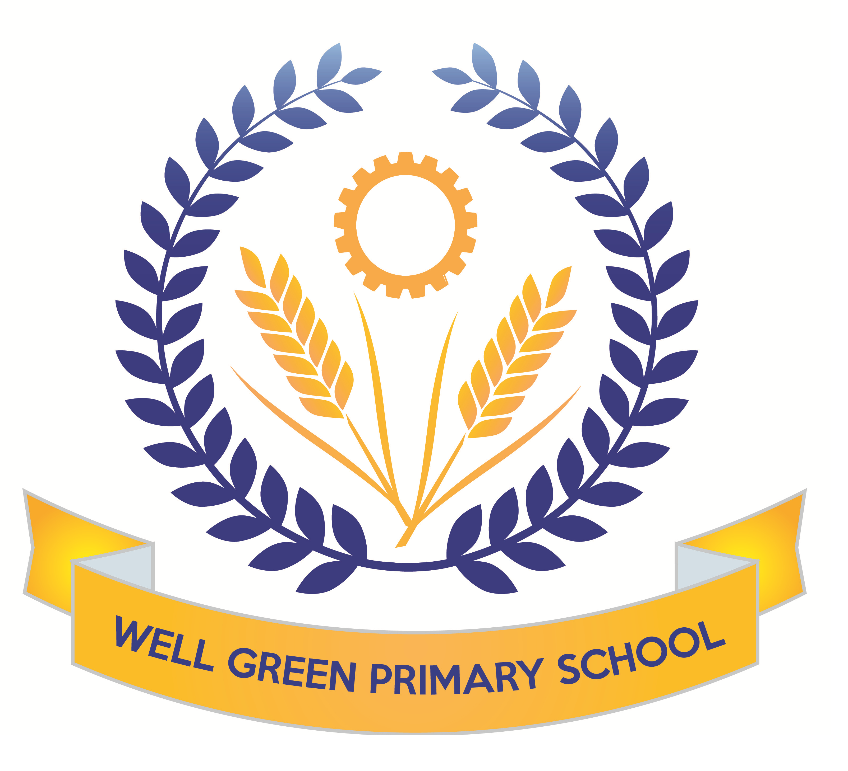

In Spring 2, the curriculum coverage and targets for Year Six will be:
English | In English, we will be covering the following texts: Discussion, Poetry- haikus, Narrative writing and reports. World Book Day: Kensuke’s Kingdom with linked writing and topic work to create a ship’s log, newspaper report and suspense story. Grammar: SPAG rules, complex sentences, investigating conditional and modal. Past participle and progressive and perfect tenses, types of pronouns.  Spelling: using rules and exceptions, suffixes and prefixes, root words. Key revision of words on Y5/6 curriculum list.
English targets | - To revise all key concepts of SPAG covered  - I can use semi-colons, colons or dashes to mark boundaries between independent clauses and use a colon to introduce a list  - I can use the progressive form of different tenses  - I can further develop my understanding of adding prefixes and suffixes to root words  - I can spell all words from the Y3/4 list and most words from the Year 5/6 list  - I can answer questions about a range of texts using inference and commenting on the use of language and how this contributes to overall meaning and provide quotations for 2 and 3 marks  - I can answer questions about fact and opinion in a text
Mathematics | We will complete our measures work, calculating the area and perimeter of shapes, including triangles and parallelograms. This will also involve working out volumes of cuboids. We will look at statistics and how to interpret and draw line graphs and pie charts. We will also learn about algebra- solving problems with unknown variables and building formulae. Finally we will be learning about ratio, including calculating ratio and solving ratio and proportion problems.
Maths targets | - To calculate area and perimeter of shapes  - To calculate volume of cuboids  - To find rules in a sequence and form algebraic expressions  - To understand ratio language and use the ratio symbol  - To calculate ratio and scale factors  - To read, interpret and draw line graphs and pie charts  - To calculate the mean  - To be able to solve multi-step problems using reasoning
Science | We will be finding out about electricity in our science work. We will build on work covered lower down school to construct circuits in parallel and series and test the brightness of bulbs and make buzzers and switches operate. We will use correct scientific symbols to record circuits. The children will carry out practical investigations in addition to developing their understanding of electrical safety and sustainable energy sources.  We will be covering revision topics for materials and properties, microorganisms and space.
Geography | For our geography work this half term, we will complete our work on rivers, learning about pollution in rivers and the impact of this. This half term we will also be using the book, Kensuke’s Kingdom, to cover some mapping skills. We will be using maps to find 8 point compass directions, 6 figure grid references, plotting time zones on world maps and plotting a course to sail around the world.
Computing | This half-term we will be focusing on ‘Online Safety’ and ‘Networks’. We will develop our understanding of what a digital footprint is and think about appropriate online behaviour. We will also think about balancing screen time with other parts of our lives. In our ‘Networks’ topic, we will learn the difference between the World Wide Web and the Internet and find out what a LAN and WAN are.
P.E. | We will be following an indoor unit with Miss George on handball. We will be learning about the rules of the game and the fats paced nature of the ball throwing skills.  For our outdoor sessions, we will be covering Netball skills to be able to develop team tactics to score and pass the ball. We will play in different positions and discuss match skills and rules of the game.
Music | Working with Mrs Cooper, Sounds & symbols, Pitched notes to create melody  Easter songs and hymns for our concert.
DT | This half term, the children will develop their use of science and electrical circuits to design and make an electrical item such as a wire hoop game. They will consider the types of materials and the finished product design for being user friendly and economical. The children will focus on their circuit and switch combination to use series and parallel aspects of design.
Art and Design | The children will use the theme of rivers to continue to think about the textures and colours in the river landscape. We will use fabrics and materials to complete weaving using lose weave hessian materials to replicate the river landscapes.
R.E. | The children will focus on the question: what difference does it make to believe in Ahimsa (harmlessness), Grace (the generosity of God) and Ummah (community)? They will make connections between beliefs and behaviour in different religions for Christianity, Islam and Hinduism. The children will learn about Easter traditions and religious celebration for Christians and how they celebrate this major festival.
P.S.H.E. & Citizenship | As part of the theme, ‘Good to be Me’ The children will be discussing strategies for dealing with anxieties and worries (linked to exams and secondary school transitions) and using assertiveness. Individual Liberty will be our focus for British Values and we will discuss Growth Mindsets in more detail to talk about realistic and achievable goals based on our own abilities. We will link our work in PSHE with computing to focus on E-Safety in detail, to talk about how increased independence brings the need for increased responsibility to keep ourselves and others safe.
French | The children will consolidate their conversational skills with places around town and ‘then and now’. They will develop their vocabulary and learn about Easter customs and traditions in France.

Weekly homework will be handed out on Friday, to be returned to school by the following Wednesday.

Spelling Test: Friday Mental Arithmetic Test: Thursday Guided Reading: Monday

P.E.: Tuesday (outdoor fitness), Friday (gymnastics indoors)

Please can you also ensure your child has the correct equipment required for school: A blue cartridge pen with spare refills, pencil, ruler, glue stick and eraser. They also require a named water bottle.

Thank you for your continued support and co-operation.
Mrs Bell

