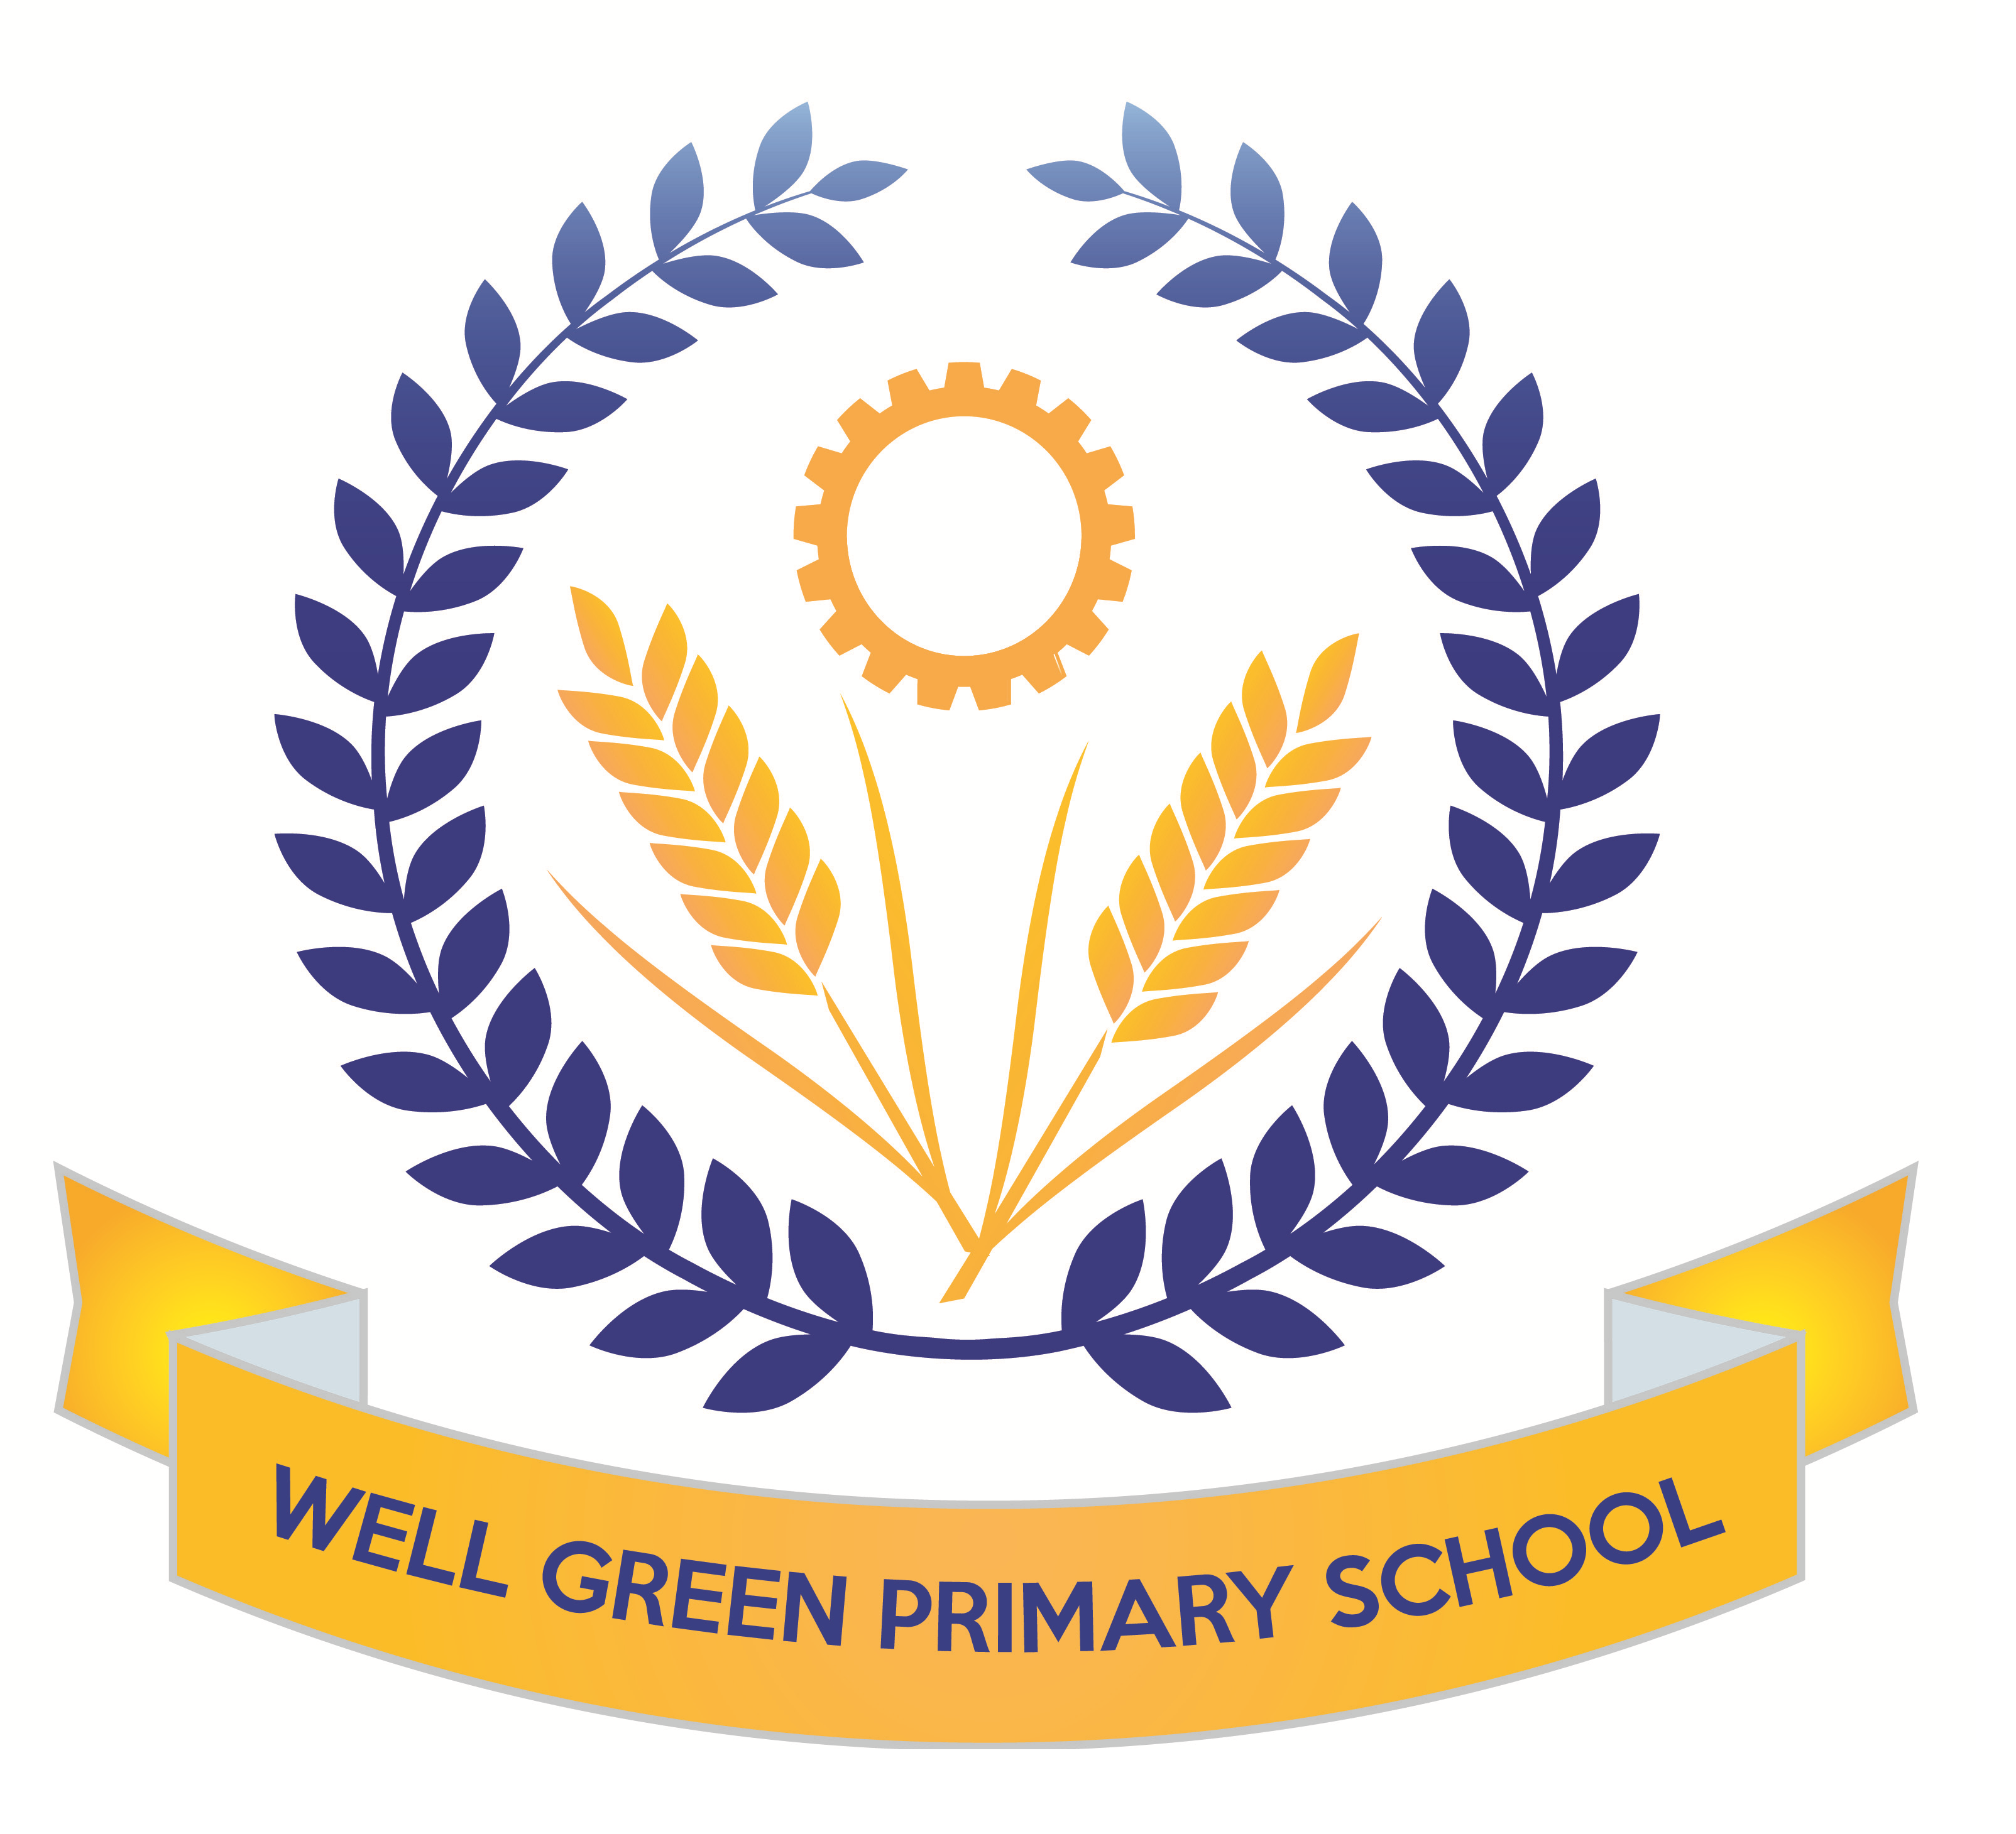

This half term (Summer 1), Year Six will be learning about the following topics:
English | Texts: suspense story about Michael on a desert island; descriptive about favourite meal; newspaper article about Michael’s disappearance and non-fiction information text about wolves from North America.  Reading- comprehension skills and revision of question types for tests (fact/ opinion and true/ false) and 3 mark answers with PEE (point, evidence and explain)  Grammatical terminology, syntax and punctuation rules and their application in preparation for the SPAG test.  Spelling: Revision of key word list for Y3/4 and Y5/6  consolidation of spelling rules, using known root words, prefixes and suffixes.
English targets | - To revise all key concepts of SPAG covered and know the key terminology  - To be able to identify different types of pronouns- relative, personal and possessive  - To be able to spell words from the key words list from Y3/4 and Y5/6 (as many as possible)  - To recognise the past perfect and past progressive tenses and be able to use these  - To be able to identify words as conjunctions or prepositions in sentences  - To be able to use a full range of punctuation in writing and apply key spellings and use neat handwriting
Maths | Revision of formal written and mental calculation methods for +, -, x & ÷.  Shape and geometry for properties of 2D/3D shapes with Mrs Burnham.  Statistics and data handling - extracting information from tables, pie charts, bar charts and line graphs to solve problems with Mrs Oldham.  Position and direction, coordinates in all four quadrants for translation, reflection and plotting. Revision of all areas and reasoning skills
Maths targets | - To revise all key concepts covered in Maths  - To develop calculations skills using written arithmetic, including to calculate written division with a formal method with decimal and fraction remainders  - To be able to solve problems involving angles in shapes  - To plot coordinates in four quadrants and translate, rotate and reflect shapes  - To be able to identify different parts of a circle  - To be able to use line graphs and conversion graphs to solve problems
Science | General consolidation and revision of all key areas of study in KS2 in preparation for assessment. We will also begin to cover the topic ‘evolution and inheritance’ and begin to study the theory of Charles Darwin and how species have evolved, including a focus on dog breeds and inherited characteristics. We will explain the similarities and differences between the process of reproduction in plants and animals and catagorise differences in living things and their offspring. We will explore the structure of the heart and investigate the effect of exercise on pulse rate. We will explain the possible effects of too much sugar in the diet on how the human body functions. Then we will begin Chemistry experimenting with ways to separate pebbles and silt in a solution of salt.
Computing | Use of SPAG.com, My Maths and BBC revise wise websites for revision purposes.  Working with Mrs Oldham focusing on ‘Text Adventures’. We will plan and create a story-based adventure in 2Create a Story. We will contrast a map-based game with a sequential story-based game. Also, we will learn to create our own text-based adventure based upon a map.
Geography | We will begin our work in Geography based on North America and the USA.  We will be mapping the states and countries and learning about the geographical significance of this part of the world. We will study climate regions, tourist attractions, agriculture and industry patterns and the landscapes.
History | The children will begin to study the Ancient Islamic civilisation of Baghdad and the golden age of Islam. They will map the empire and the spread of this and learn about the daily life at this time. The lessons will include a focus on the House of Wisdom, The Silk Road, geometry and calligraphy.
DT/Art | This half term, the children will continue to develop their use of science and electrical circuits and design and make an electrical item such as a burglar alarm or wire hoop game.  We will also create art work using weaving of fabrics and materials.
Music | Performance songs-singing in two parts and accompaniments  Beginning to learn songs for the performance and develop music to accompany.
P.E. | Cricket- weekly sessions to develop skills with a specialist coach and work on matches and develop scoring systems.  Orienteering using school orienteering course to develop out door and adventurous
R.E. | Beliefs and Practices  Islam and Humanism  The life and teachings of the Prophet Muhammad linked to work in history in Summer 2 on Ancient Islamic Civilisations  Visit for curriculum enhancement to develop knowledge and understanding of Islamic faith and practices,
P.S.H.R. E. & Citizenship | We will have a focus on Relationships:  -Knowing myself, understanding & managing my feelings, understanding the feelings of others, developing social skills and making choices  Safe & Healthy Relationships:  - Do gender stereotypes have an impact on our behaviour?  Our British Values focus for this half term is tolerance.  RSE week commencing 20th May  Sex and relationships education  Lessons will focus on the Y6 content for RSE  Scientific names for male and female reproductive systems  Understand how a baby is conceived, develops and is born

Most weekly homework and revision will be handed out on Friday, to be returned to school by the following Wednesday. Children have SPAG.com accounts/ My Maths access to complete online revision and preparation as directed by the teachers.

Y6 booster groups will continue until the week beginning 6th May before children complete their SATs tests.

Spelling Test: Friday Mental Arithmetic Test: Thursday
Cricket: Friday PE: Friday (Orienteering)

Please can you also ensure your child has the correct equipment required for school: A blue cartridge pen with spare refills, pencil, ruler, glue stick and eraser. They also require a named water bottle.

Thank you for your continued support and co-operation.

Mrs Burnham and Mrs Oldham

Key stage 2
The key stage 2 tests are timetabled from Monday 13th May to Friday 17th May 2024.
There is a timetable below showing the details of the tests being held in school for the week commencing 13th May for the Y6 children.
Please ensure children arrive in school promptly this week and have a good night’s sleep and good breakfast to enable them to achieve their very best during these external exams.
Results of the tests will be published in July and will be reported to parents in the end-of-year reports.
Date | Activity
Monday 13th May | English grammar, punctuation and spelling Paper 1: questions  45 mins
Monday 13th May | English grammar, punctuation and spelling Paper 2: spelling  15 mins
Tuesday 14th May | English reading  1 hour
Wednesday 15th May | Mathematics Paper 1: arithmetic  30 mins
Wednesday 15th May | Mathematics Paper 2: reasoning  40 mins
Thursday 16th May | Mathematics Paper 3: reasoning  40 mins
Friday 17th May Internal writing assessment tasks

