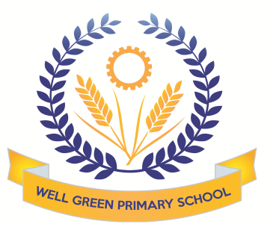

This half term (Summer 2), Year Six will be learning about the following topics:
English | We will be reading ‘A Thousand and One Arabian Nights’ to link with our Islamic Civilisation work in history.  We will also be focusing on speaking and listening objectives for our performance of  ‘Aladdin’ and knowledge of play scripts to interpret stage directions and use drama skills.  We will develop our cross-curricular writing to write our geography and history topics.
English Targets | - To develop speaking and listening skills to respond as an audience  - To use drama skills and intonation to tell a story  - prepare poems and plays to read aloud and to perform, showing understanding through intonation, tone and volume so that the meaning is clear to an audience
Maths | Consolidation of our work in year 6. Transition maths activities. Mental Arithmetic  Statistics work- studying climate data for North America to create tables and charts. Comparing temperature and rainfall ranges and means.
Science | We will focus on learning more about evolution and inheritance, continuing on themes we covered when learning about adaptations in animals. We will learn more about Darwin’s theory and inherited characteristics.
ICT | Searching the internet for information to support other curriculum areas.  Creating presentations and sound work for our performance
Geography | We will continue our work in Geography based on North America and the USA.  We will be mapping the states and countries and learning about the geographical significance of this part of the world. We will study climate regions, tourist attractions, agriculture and industry patterns and the landscapes.
History | We will be learning about the Islamic Civilisation in Baghdad in 900 AD. We will be finding out about the Prophet Mohammed and the influence and rise of Islam. The work will include considering why Baghdad was central in the Islamic Empire.
DT/Art | This half term, the children will be creating a balanced and healthy simple meal using cookery skills. They will be chopping, slicing, dicing and cubing vegetables in this process. We will focus on Middle Eastern food including making our own hummus, cous-cous salads, naan breads and sampling different herbs and tastes.  We will create art work based on the theme on North America, using printing techniques for city landscapes.
P.E. | Athletics- we will cover a range of outdoor athletic lessons to develop our skills and techniques  with long and high jumping, throwing and various distances of running. We will be participating in  Sport’s Day.  The children will also develop their tennis skills using the new equipment in school to practise ball control, passing techniques and matches.
Music | Beginning to learn songs for the performance and develop music to accompany.  Aladdin music for our performance.
R.E. | Local study – Independent project on different faiths and religions.
P.S.H.E. & Citizenship | Dragon’s Den workshop- Explore Learning  Conquering goals- Robinwood team activities

Key Dates:
- 20-22nd June Robinwood
- 17th June Green Day
- Thursday 23rd June- School closed for polling day
- Friday 1st July Sport’s Day (sport activities week)
- Tuesday 19th July Y6 leaver’s performance of Aladdin
- Wednesday 20th July Y6 leaver’s performance of Aladdin
- Friday 15th July- Reports go home with SATs results
- Monday 25th July – Leaver’s Disco
- Thursday 21st July open afternoon/evening
- Tuesday 26th July Leaver’s Assembly (am)
- Wednesday 27th July –final day of term.

Thank you for your support and co-operation this year. Miss Burnham

