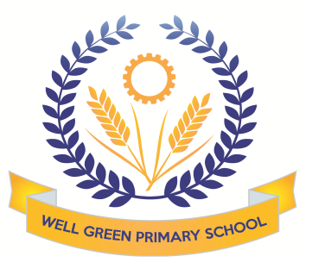

In Summer 2, the curriculum coverage and targets for Year Six will be:
English | Writing moderation and assessment piece based on North American wolves. Drafting and editing skills to improve our written work based on feedback.  We will be reading Storm Breaker as our whole class guided reading text to unpick suspense and intrigue in the text.  We will also be focusing on speaking and listening objectives for our performance of  ‘Peter Pan’ and knowledge of play scripts to interpret stage directions and use drama skills.  We will develop our cross-curricular writing in our geography topic.
English Targets | - To draft and edit writing based on feedback  - To develop speaking and listening skills to respond as an audience  - To use drama skills and intonation to tell a story  - prepare poems and plays to read aloud and to perform, showing understanding through intonation, tone and volume so that the meaning is clear to an audience
Maths | Consolidation of our work in year 6. Transition maths activities. Mental Arithmetic  Statistics work- studying climate data for North America to create tables and charts. Comparing temperature and rainfall ranges and means.
Science | We will focus on learning more about evolution and inheritance, continuing on themes we covered when learning about adaptations in animals. We will study the theory of Charles Darwin and how species have evolved, including a focus on dog breeds and inherited characteristics. We will learn about scientific theory about how humans evolved from apes.
Computing | Our unit on Purple Mash this half term is all about quizzing. We will learn how to make different types of quizzes using different programs, such as 2Quiz, 2DIY and 2Investigate.
Geography | We will be learning about North America and the USA. We will be mapping the states and countries and learning about the geographical significance of this part of the world. We will study climate regions, tourist attractions, agriculture and industry patterns and the landscapes.
DT/Art | This half term, the children will be creating a balanced and healthy simple meal using cookery skills. They will be chopping, slicing, dicing, sautéing and cubing vegetables in this process. We will focus on designing and making our own version of a healthy lasagne.  We will create art work based on the theme on North America, using printing techniques for city landscapes.
P.E. | Athletics- we will develop our skills and techniques with long and high jumping, throwing and various running distances ready to participate in Sports Day.  We will play some Rounders and the children will also develop their Frisbee skills to practise ball control, passing techniques and matches.
Music | Beginning to learn songs for the performance and develop music to accompany Peter Pan music for singing and choreography for our performance.
R.E. | Continuing exploring the beliefs and traditions of Islam, we will explore Eid celebrations and the rituals of Wudu and prayer and exploring the meaning of humanism.
P.S.H.E. & Citizenship | As part of our British Values work on democracy, we will be taking part in an exciting project this half term linked to our work earlier in the year about the magistrates and their role in the community.  We have been invited to attend a mock trial in Manchester and will be doing extensive work to prepare for the court room scene and undertaking prosecution and defence roles in the trial.  Conquering goals- Robinwood team activities  As part of our SEAL work, we will focus on changes as we will be preparing for transition and secondary school routines.  We will also be covering SRE week on the 21st June 2021  This will include watching the DVDs from the school approved scheme with a focus on conception, child birth, puberty and changes to the body.

Thank you for your support and co-operation throughout the year.
Mrs Bell

